College of Engineering and Computing
Staff Awards Guidelines

The College of Engineering and Computing invites applications for the Staff Awards for the 2021-2022 academic year. The awards will be given in the categories of (1) Institutional, Strategic, and Operational Excellence; (2) Knowledge and Achievement; and (3) Service Excellence. All eligible administrative and staff employees, with or without nomination, are welcome to apply.

Application Documentation

- Application form (required)
- Resume (required)
- Personal statement summarizing accomplishments (with emphasis on those over the last three years) in the chosen category (maximum two pages in length) (required)
- Annual Evaluation: The most recent annual evaluation by the applicant’s supervisor. (required)
- Endorsement Letter(s): Letters from students, faculty, administrators or staff colleagues explaining why they feel the applicant should receive the award. (maximum of two letters, each letter maximum one page in length) (optional)

Applications missing any of the required documents will not be considered.

Eligibility

The specific eligibility requirements for each award are listed in the individual award sections below. The following restrictions also apply:

- Applicants must be full-time staff members of CEC.
- Applicants who received a college award in the same category have to wait for a minimum of three academic years to become eligible to apply for the same award again (i.e., must not be listed for the same award category on the CEC Faculty and Staff Awards page, at https://cecfc.fiu.edu/faculty-and-staff-awards/, since the 2019 list of award winners).
- Applicant must apply to only the award category that matches their career role categories below.

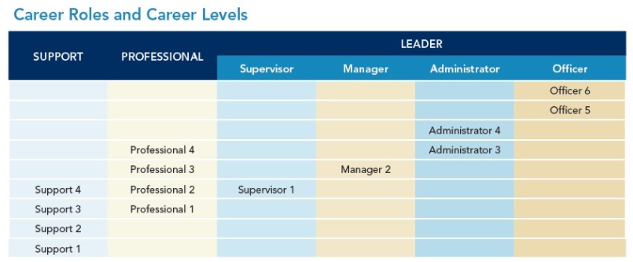

The Awards Committee reserves the right to make no award for any of the award categories.

- Institutional, Strategic, and Operational Excellence

Eligibility:

- Applicants applying for this award must be employed in the Leader career role category (including Supervisor, Manager, Administrator, and Officer) of all career levels.
- Applicants applying for this award for the first time must have been working at FIU for at least three academic years (i.e., hiring date no later than August 2019).

Criteria:

- Supported institutional, strategic, and operational excellence by restructuring processes to improve efficiency, productivity and quality;
- Implementing critical programs; and/or
- Receiving recognition from peers in the academic community for excellence in research, scholastic, or creative activities.

- Knowledge and Achievement

Eligibility:

- Applicants applying for this award must be employed in the Professional career role category of all career levels.
- Applicants applying for this award for the first time must have been working at FIU for at least three academic years (i.e., hiring date no later than August 2019).

Criteria:

- Served as a role model for the pursuit, generation, dissemination, and application of knowledge through professional development, mentorship, and/or peer development.

- Service Excellence

Eligibility:

- Applicants applying for this award must be employed in the Support career role category (AFSCME employees) of all career levels.
- Applicants applying for this award for the first time must have been working at FIU for at least three academic years (i.e., hiring date no later than August 2019).

Criteria:

- Provided excellent service to faculty, staff and/or students.
- Demonstrated commitment to service by exceeding expectations in the areas of telephone etiquette (making internal and external customers feel welcome and respected when they call on the telephone), responsiveness (demonstrating responsiveness to internal and/or external customers’ requests for services and/or information), helpfulness (providing accurate and relevant services and information to internal and/or external customers), and/or teamwork (fostering cooperation and collaboration with internal and/or external customers).

